**Name:** Nishan Paul

**ID:** 1604085

**Course Title:** Computer Graphics (Sessional)

**Course No:** CSE-458

**Level 4, Term 1**

**Assignment 06**

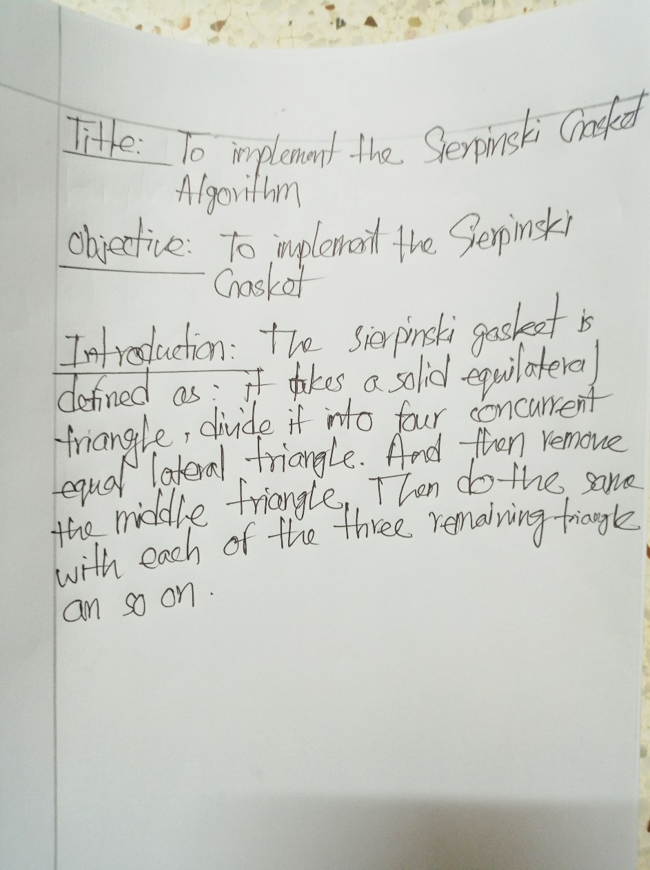

**Code:**

#include<windows.h>

#include<GL/glut.h>

#include<bits/stdc++.h>

#define PI 3.141592654

float width=500, height=500;

void gasket(float x1,float y1,float x2,float y2,float x3,float y3, int n) {

float x12,y12,x13,y13,x23,y23;

if(n>0) {

x12=(x1+x2)/2;

y12=(y1+y2)/2;

x13=(x1+x3)/2;

y13=(y1+y3)/2;

x23=(x2+x3)/2;

y23=(y2+y3)/2;

gasket(x1,y1,x12,y12,x13,y13,n-1);

gasket(x12,y12,x2,y2,x23,y23,n-1);

gasket(x13,y13,x23,y23,x3,y3,n-1);

}

else {

glBegin(GL_TRIANGLES);

glVertex2f(x1,y1);

glVertex2f(x2,y2);

glVertex2f(x3,y3);

glEnd();

}

glFlush();

}

void c_curve(float x, float y, float len, float alpha, int n) {

if(n>0) {

float offset = (60*PI)/180;

c_curve(x,y,len,alpha+offset,n-1);

x=x+len*cos(alpha+offset);

y=y+len*sin(alpha+offset);

c_curve(x,y,len,alpha-offset,n-1);

}

else {

glBegin(GL_LINES);

glVertex2d(x,y);

glVertex2d(x+(len*cos(alpha)),y+(len*sin(alpha)));

glEnd();

}

glFlush();

}

void display(void) {

float x, y, len, x1, y1, x2, y2, x3, y3, radian, degree = 0;;

x = -25;

y = 25;

len = 50;

x1=x;

y1=y;

radian = (degree*PI)/180;

c_curve(x,y,len,radian,1);

x = x+(len*cos(radian));

y = y+(len*sin(radian));

x2=x;

y2=y;

degree = 180+108;

radian = (degree*PI)/180;

c_curve(x,y,len,radian,1);

x = x+(len*cos(radian));

y = y+(len*sin(radian));

degree = 216;

radian = (degree*PI)/180;

c_curve(x,y,len,radian,1);

x = x+(len*cos(radian));

y = y+(len*sin(radian));

x3 = x;

y3 = y;

degree = 144;

radian = (degree*PI)/180;

c_curve(x,y,len,radian,1);

x = x+(len*cos(radian));

y = y+(len*sin(radian));

degree = degree-72;

radian = (degree*PI)/180;

c_curve(x,y,len,radian,1);

gasket(x1, y1, x2, y2, x3, y3, 1);

}

void init(void) {

glClear(GL_COLOR_BUFFER_BIT);

glClearColor(0,0,0,0);

glMatrixMode(GL_PROJECTION);

glLoadIdentity();

gluOrtho2D(-100,100,-100,100);

}

int main(int argc, char** argv)

{

glutInit(&argc, argv);

glutInitDisplayMode(GLUT_SINGLE | GLUT_RGB);

glutInitWindowSize(width,height);

glutInitWindowPosition(100,100);

glutCreateWindow("lab 7");

init();

glEnable(GL_POINT_SMOOTH);

glutDisplayFunc(display);

glutMainLoop();

return 0;

}

**Output:**



